# Instructions: Parish Register with Plague Deaths Indicated

Instead of one of the weekly Bills of Mortality, you have been assigned a parish burial register. Some registers indicate which burials were deemed to be plague victims, while others do not; your assigned register **does** make this distinction. This will be your contribution to our class-sourced database of the London plague statistics from 1665.

**Your parish name is:______________________________________________________**

Once you have logged into Remote Desktop and opened oXygen XML Editor (see on separate instruction sheet), open a browser, go to Canvas, and open the assignment “Collaborative digital edition: Bills of Mortality”.

In that assignment page, scroll down to where you see a link for the file Parish-name-register-with-causes.xml. Click to download the file. Then go to oXygen, File -> Open, and locate Parish-name-register-with-causes.xml in your Downloads folder. Open it in oXygen.

Your oXygen window will be cluttered with a bunch of boxes around the sides and possibly the bottom. Hit the X in the upper right corner of each of these until they are all gone; you don’t need them.

Now you should see your document open and taking up the whole oXygen screen:

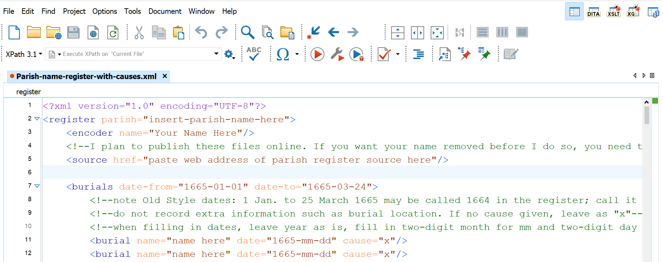

You are going to treat this as a form and enter the data from your Parish Register.

Start by changing the file name in one way only. Go to File -> Save As.

First, select where you will be saving the document: it will be saved to your OneDrive folder so you have access to it later. Put it wherever you think you will be able to find it again. Ask a fellow student for help if you need guidance on this.

Next, before you click Save, where you see the file name Parish-name-register-with-causes.xml, replace the word “name” in the file name with the name of your parish, replacing any spaces with hyphens. For example, St Alban Woodstreet would become Parish-St-Alban-Woodstreet-register-with-causes.xml:

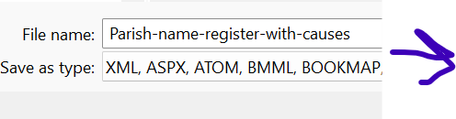 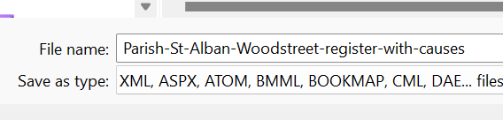

Now click “Save”. You’ll see the new file name in the tab at the top of the file in oXygen.

Next, you need to enter the same parish name, still using the hyphens, in your XML file. (See the first page of this guide for your parish name.) These go inside the quotation marks and replace the filler text there. Then enter your name in the appropriate location. Go back to the Canvas page for this assignment, and click on the link below your assigned parish’s name. This will open a pdf of the published parish register in your browser, and it should take you directly to the page where your information starts. Before you begin entering burial data, copy the URL and paste it into the appropriate field in your XML document.

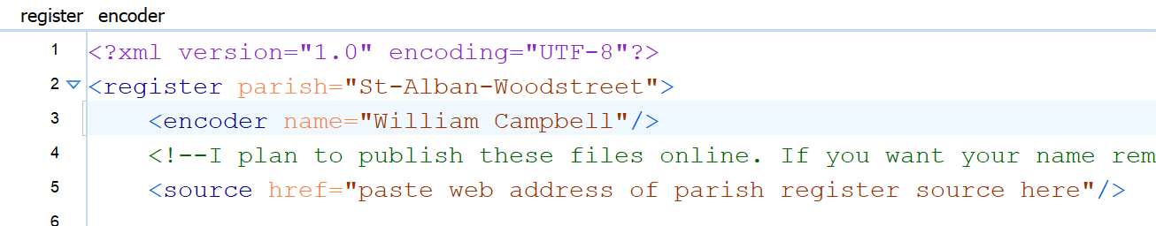

You are now almost ready to start entering the burial data; your goal is to cover all the burials from January 1, 1665 to July 1, 1666, a period of eighteen months. But first, read the instructions below carefully!

## Dates

Your XML document is divided into sections by date range, with headers such as:

<burials date-from="1665-01-01" date-to="1665-03-24">

Make sure you only enter burials from the appropriate date range in each section.

The date format **must** be 4-digit year, then 2-digit month, then 2-digit day! The computer needs them in this format.

**For dates between January 1 and March 24**: they calculated years differently then and we need to account for that. New Year’s Day was (strangely) March 25. It wasn’t moved to January 1st until 1752! So we need to convert “Old Style dates” to “New Style dates”. What the document calls January 1, 1664, is really January 1, 1665, the way we measure things. Historians have to make this conversion, and so do you. So for dates within this range, add one to the year to account for this.

For further clarification, read the green text in the <!—xml comment --> tags on your doc:

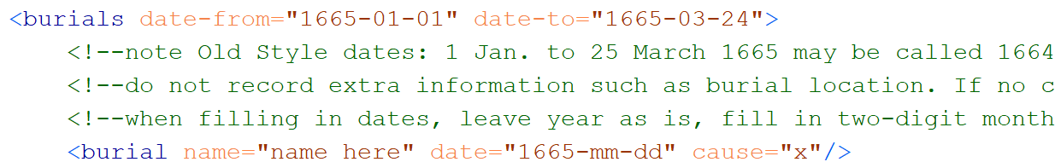

It is possible that the register may separately give a burial date and a death date. If so, for consistency give the burial date only.

Save your work now, and often as you proceed.

## Names

Each burial entry looks like this:

<burial name="name here" date="1665-mm-dd" cause="x"/>

The name in the register may be a simple as “John Smith”, but it could be more complicated, such as “Janet ye widdow of ye late John Smith, merchaunt” or “Isaac, aged 18 moneths, sonne of ye late John Smith and his wife Janet”. You do not need to type up this whole description. Simplify to “Janet Smith” or “Isaac Smith”. (If a future student team works on this material, they will fill this out then, but you have enough to do now.)

## Causes

Your register includes a notation, such as “Plag:” or “Pl” next to those burials where the decedent was deemed to have died of the plague. (These should only start mid-1665, when the plague took hold.) Where you see that in an entry, go to cause="x" in your XML document and change it to cause="p". If you do not see that, or if some other cause of death is given, leave it as cause="x". If you are unsure about the notation in your parish register, ask!

## Locations

Some registers indicate where the decedent was buried, such as “In the old burying ground” or “In ye North Aisle” (meaning under the floor inside the church building). We are **not** including this information; if it is given, omit it.

## How many entries?

The goal is to cover all entries from January 1, 1665 to July 1, 1666. I pre-populated each section of your XML document with a number of blank entries. If you see that you will need more of these lines, simply copy and paste extra lines and fill them out. When you are done with that section, delete any blank entries.

Save your work often as you go.

Check in the upper right-hand corner of your oXygen screen. There’s a color-coded square. You want this square to be **green.** If it is, then congratulations – when you have finished filling out the burial entries, you’re done with the assignment. Make sure it is saved, and submit it in Canvas the same way you submit any other assignment.

If the square is **red**, it means you made an error somewhere: perhaps you deleted some quotation marks, for example. If so, you should see some red lines on the scroll bar that will help you locate the errors in your document. Ask for help if you’re not sure why it’s red or how to fix it. Once you have fixed the errors and have a green square, save and submit your work (see above).

# What if I’m not done within our class time?

Save your work before you leave; you should be able to locate it again in OneDrive. As a backup, **also** go ahead and upload it to Canvas, but write “not finished” in your submission comment box. You should be able to download it from Canvas to keep working on it and re-submit it when you are done.

To keep working, you have three options:

1. Come back to a Pitt computer lab at another time, sign into Virtual Desktop there, open oXygen, open your file, and carry on. Submit to Canvas when you’re done.
2. You can also access Virtual Desktop over the web from a non-Pitt computer at <https://client.wvd.microsoft.com/arm/webclient/index.html> . Carry on and submit to Canvas when you’re done.
3. If for some reason you can’t get to Virtual Desktop, you should be able to open your .xml file in a plain text editor, such as Notepad (Windows/PC) or TextEdit (on a Mac). Do NOT use MS Word or any other word processor! In a plain text editor, you’ll lose some formatting (which is only there to help you see what you are doing), and you can’t check the red/green square, but in theory it should work just fine. Be sure it is still saved with a file name that ends .xml rather than .txt or anything else. Submit to Canvas when you’re done.